FASS Backup System – Progress Report (21/10/2025)
Changes made :
- Created a few key parts of the project such as the GUI and the core backup system.
  - For the GUI, we have made a simple, non final design specifically for testing other systems.
  - As for the backup system, we have created some features such as file selection, deletion and automatic backup by making structs to keep track of each file in the list of backed up files.
- Linked the GUI with features from the backup.rs file such as the file selection for example.

Plans :
- Make the program able to be ran in the background using Daemonize.
- Add quality of life feature to the program such as a viewing option where user can select a list or preview option.
- Link more feature to the GUI.
- Improve the GUI to have a more clean and user friendly design.

Problems found :
- We’ve had some issues with making the program run in the background of the user’s device via Daemonization.

Screenshots of Program :
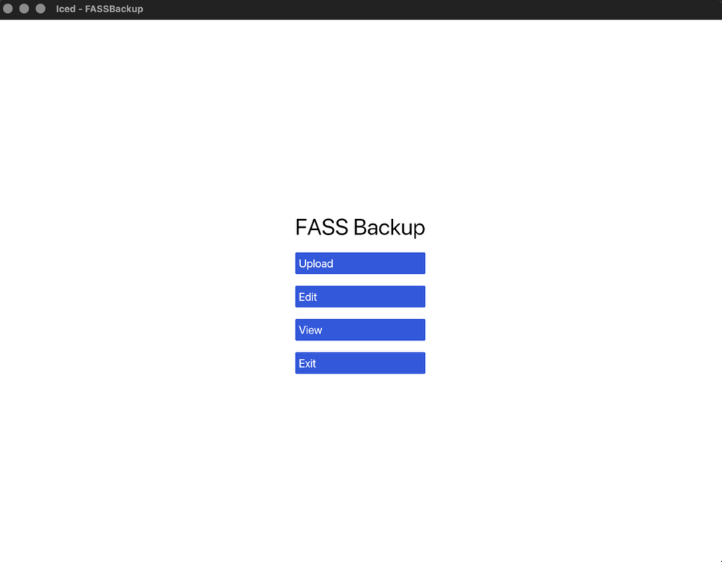
Simple program GUI for testing.

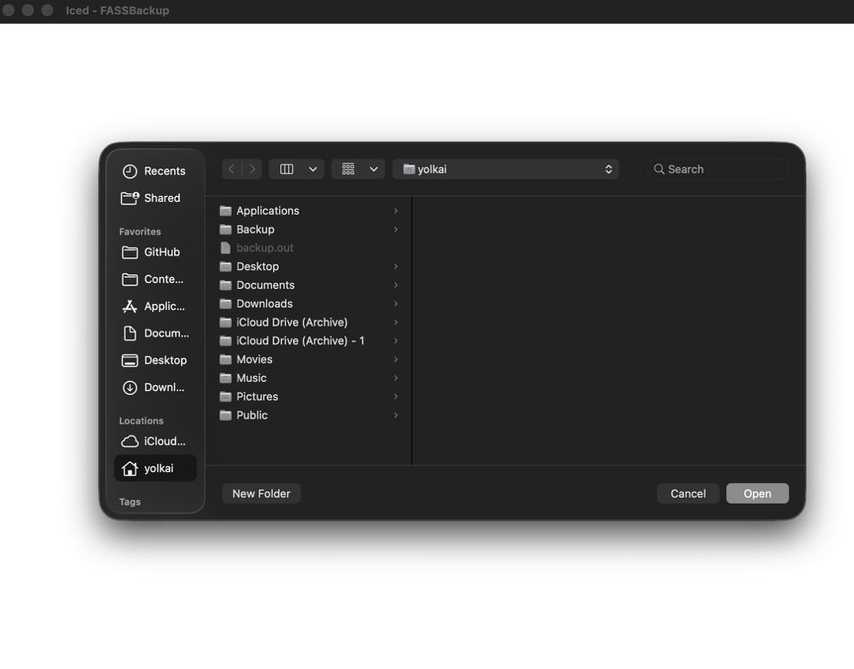
File selection pop-up.
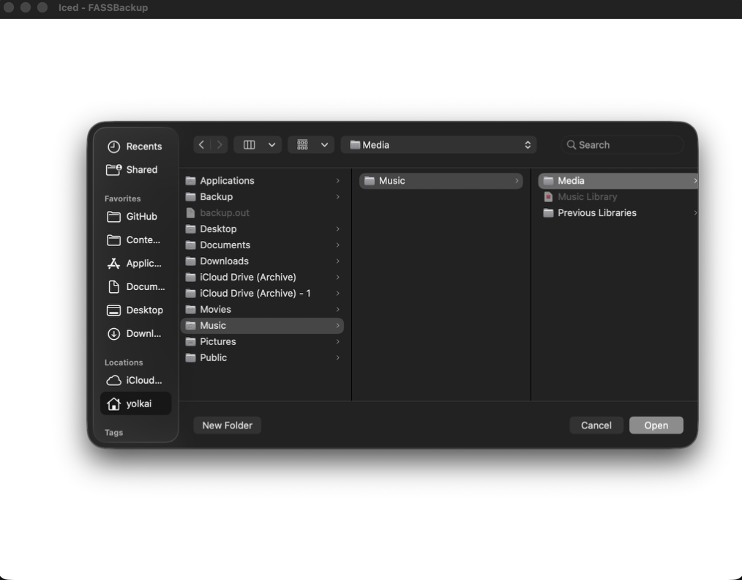
The pop-up uses the OS’s native file explorer.

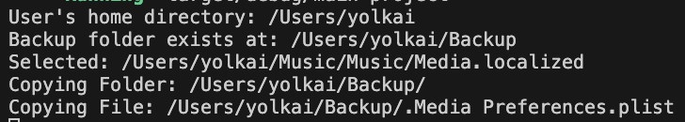
Terminal output of copying files to backup folder.
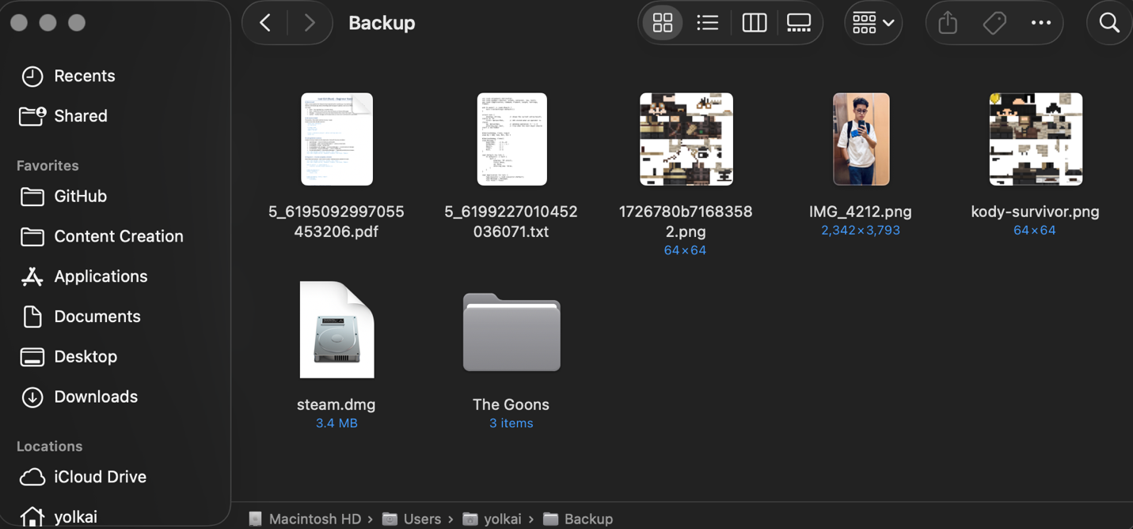
Image of backup folder containing copied files from other locations.

